**SCREENSHOTS**

1. **Mounting Azure Storage in Databricks**

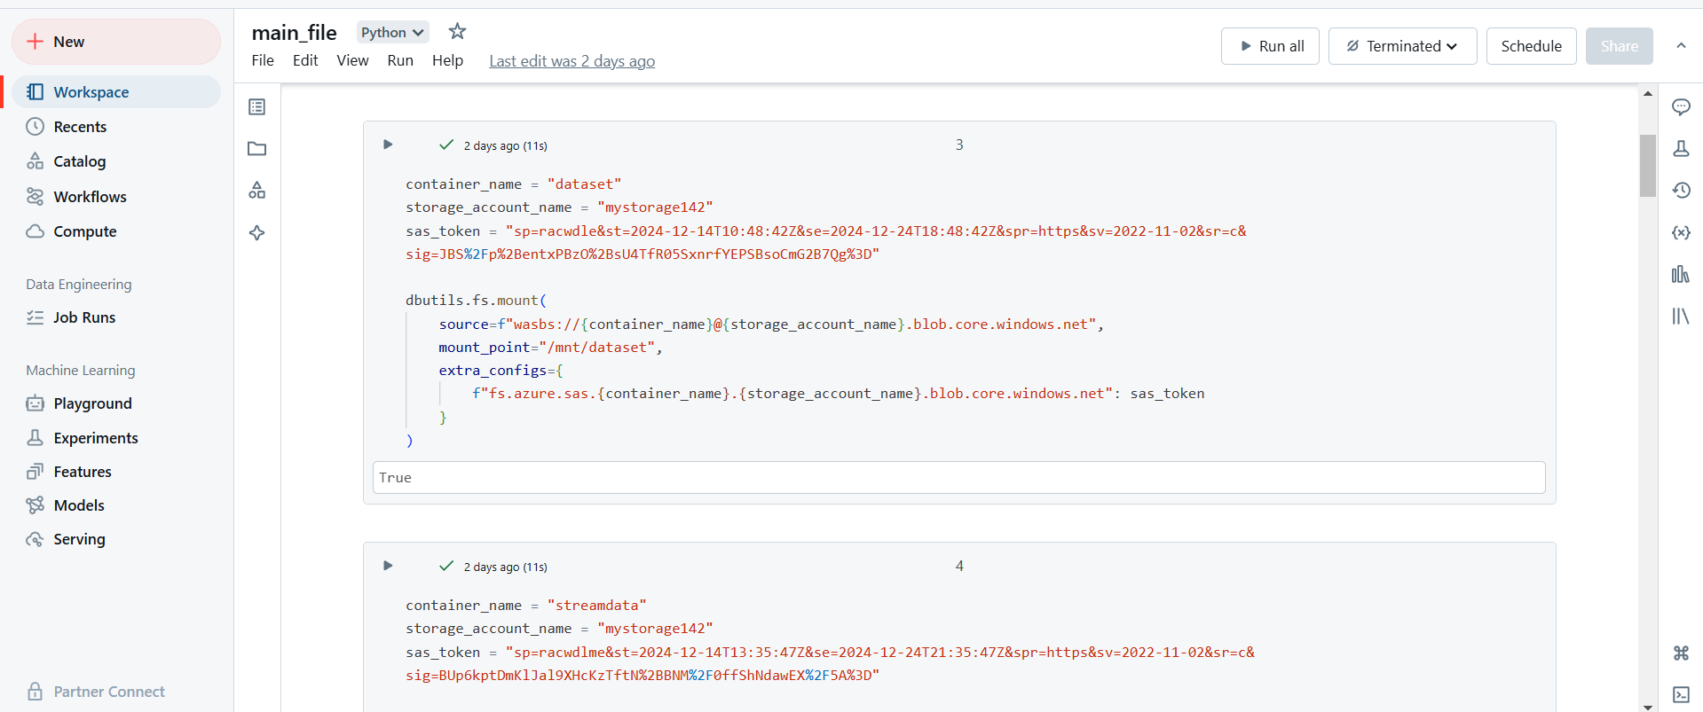

**2.Verification of Storage Mounting**

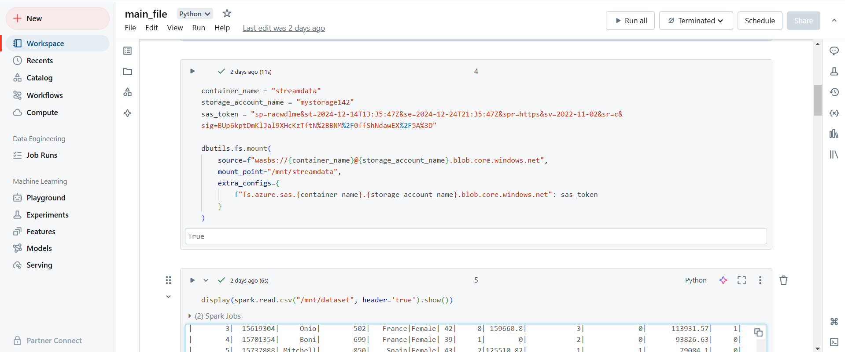

**3.Displaying Contents of Mounted Directory**

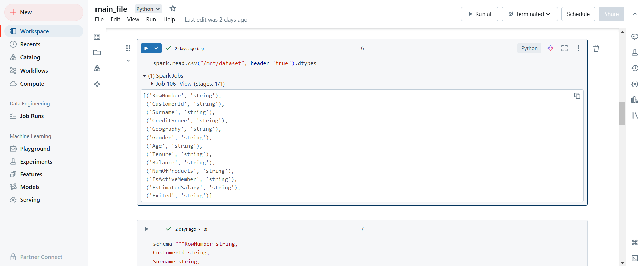

**4.Displaying File Metadata**

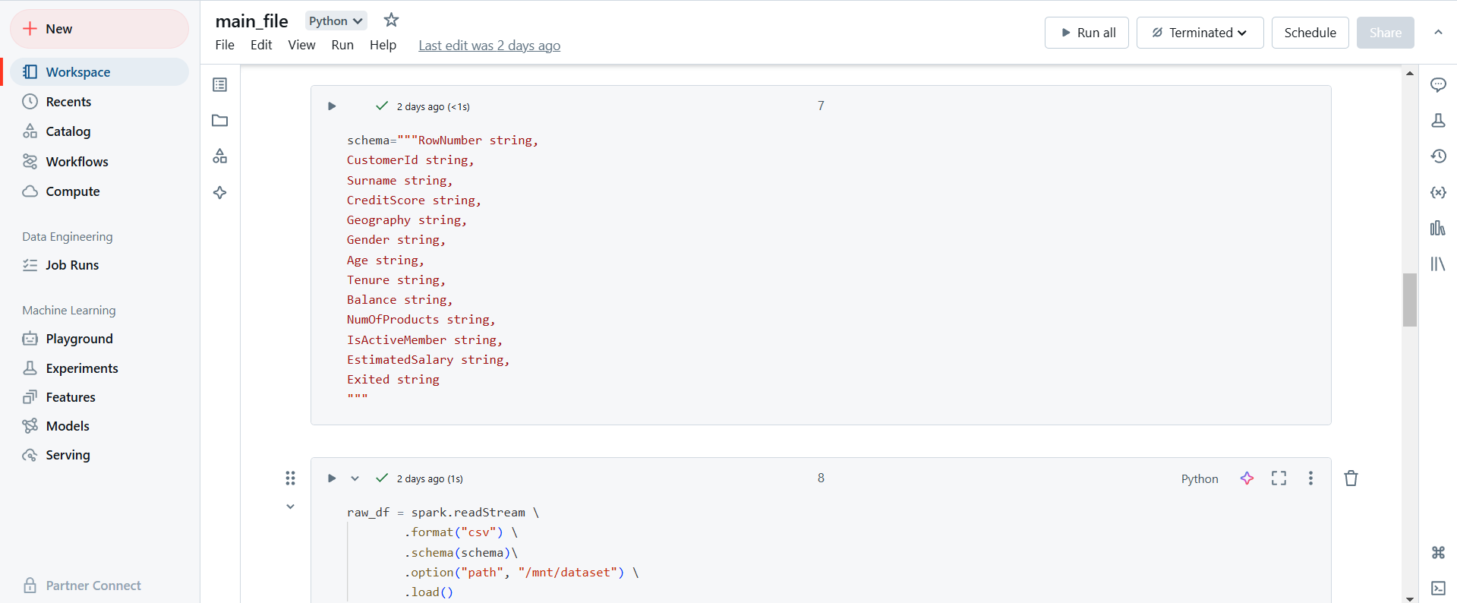

**5. Validation of File Mounting and Access**

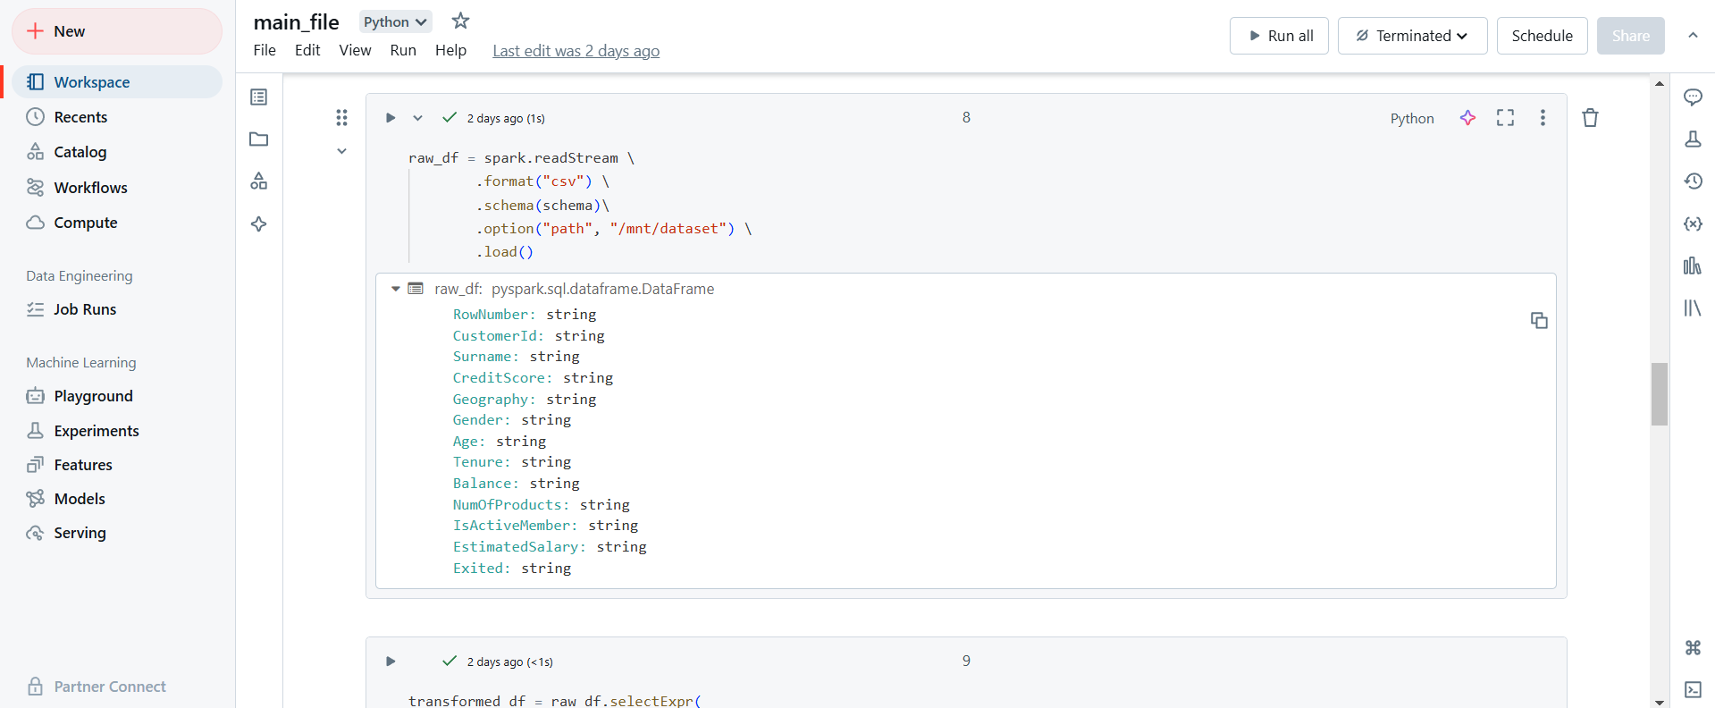

**6.Creating and Displaying PySpark DataFrame Schema**

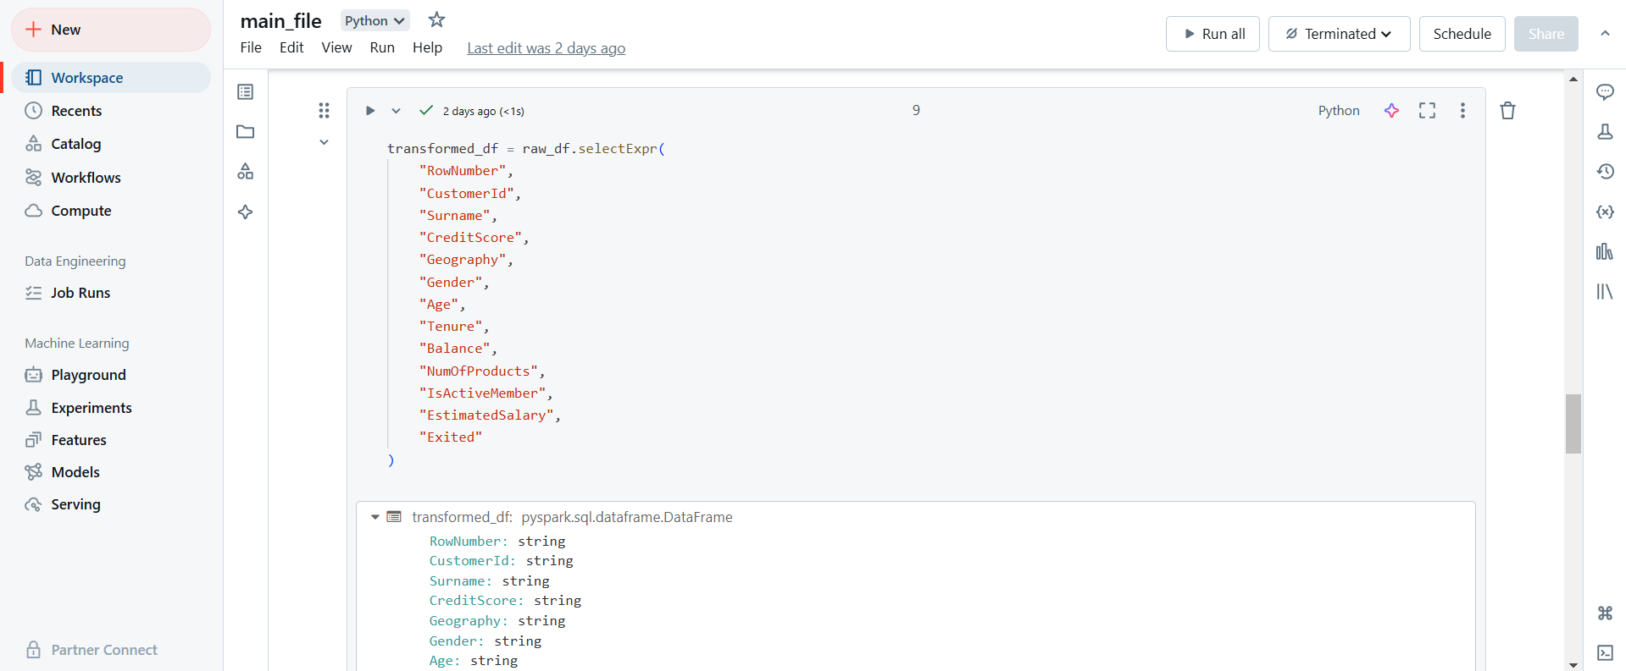

**7.Previewing Data in PySpark DataFrame**



**8.Data Transformation Using PySparkSQL**

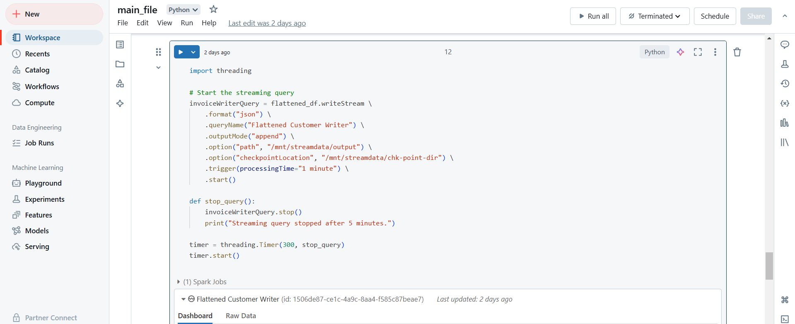

**9.Writing Transformed Data to Delta Lake**

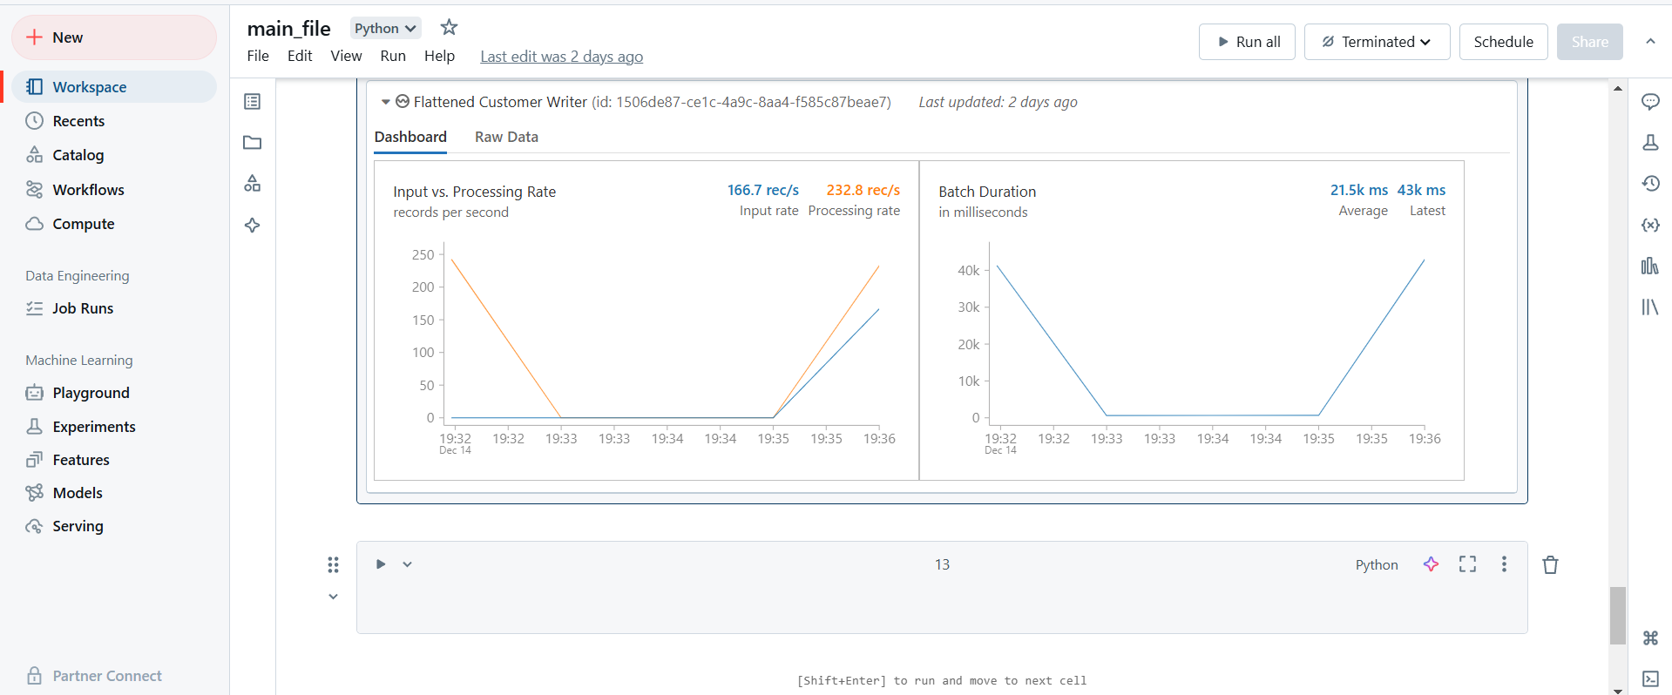

**-Data Visualization of Transformed Data**

